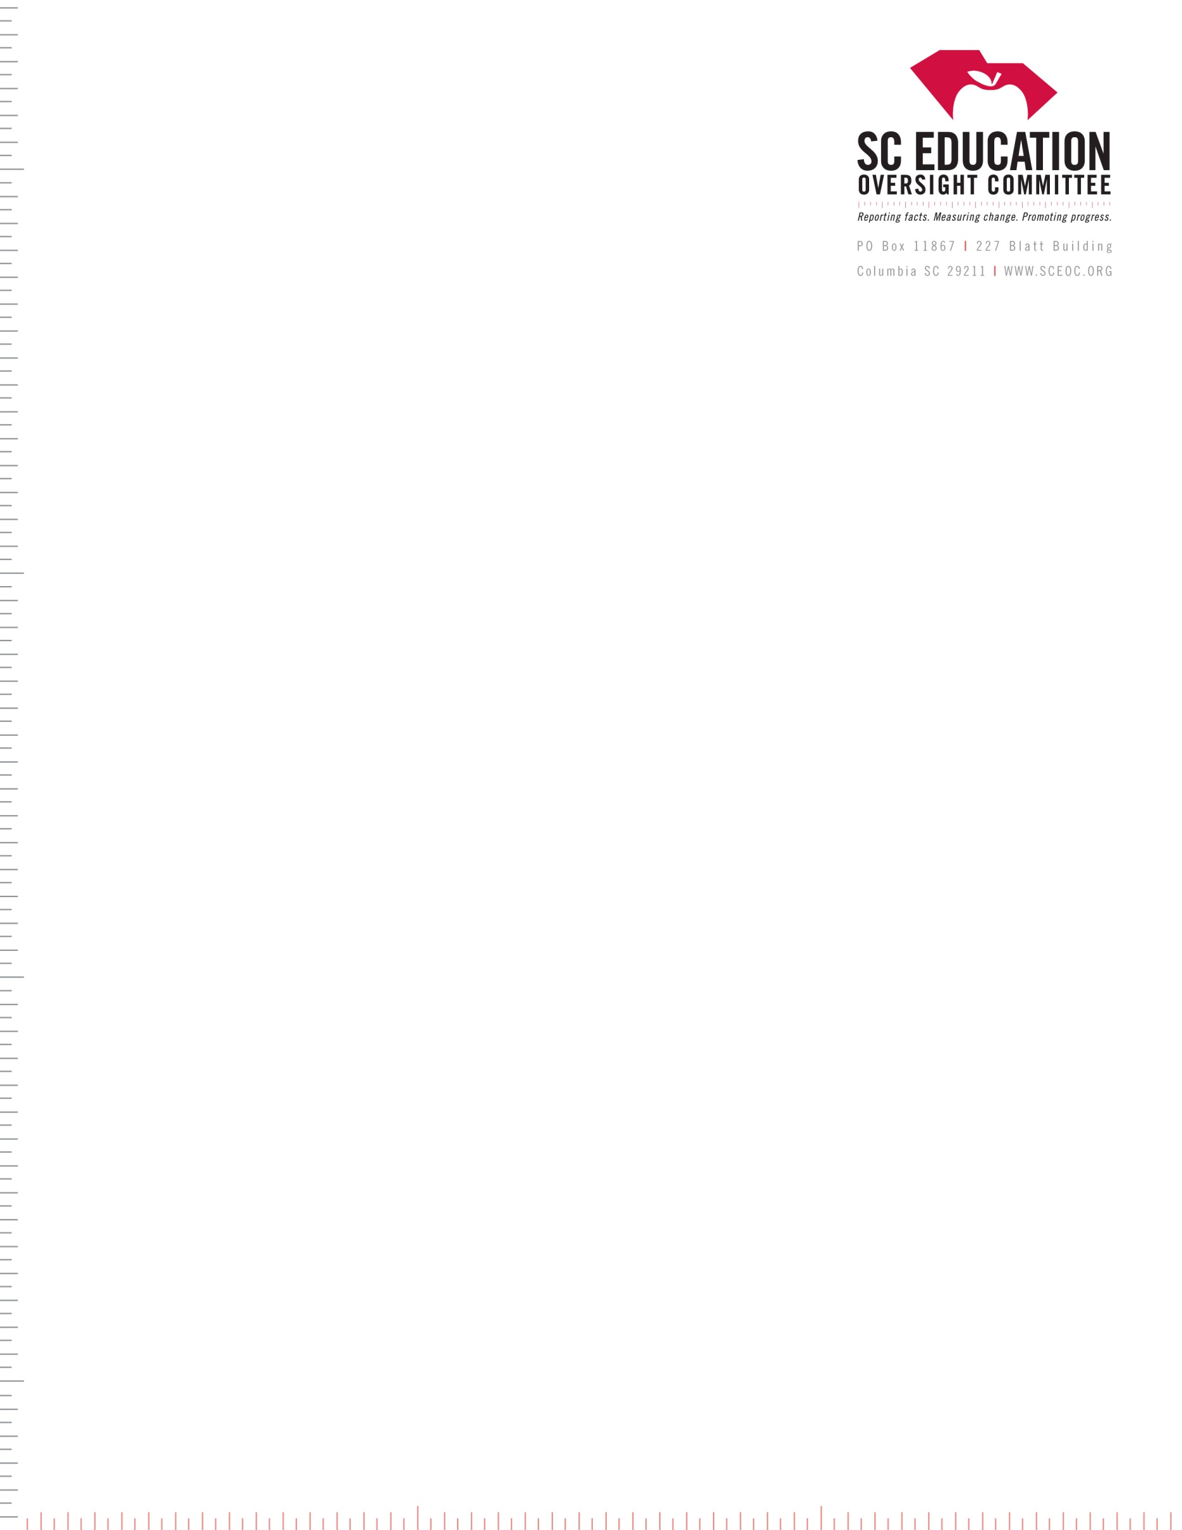

January 16, 2025

To Whom It May Concern:

State law requires that an independent school’s application to the Educational Credit for Exceptional Needs Children (ECENC) program include “a copy of a compilation, review, or compliance audit of the organization’s financial statements as relating to the grants received, conducted by a certified public accounting firm.”

The term compliance audit refers to a determination of whether the school in the prior fiscal year complied with the requirements of the Educational Credit for Exceptional Needs Children Program. The certified public accounting firm confirms in writing by **November 15, 2025** that:

* the independent school can document and verify that all grants received under the Educational Credit for Exceptional Needs Children Program in 2024-25 were for eligible children enrolled in the school;
* the independent school can document the total amount of each grant per child from Exceptional SC;
* the independent school can document that no grant exceeded $11,000 during school year 2024-25;
* the independent school returned a prorated amount of the grant to Exceptional SC if any student withdrew during the school year; and
* the total amount of each grant was used for tuition which is defined as “the total amount of money charged for the cost of a qualifying student to attend an independent school including, but not limited to, fees for attending the school and school-related transportation."

Sincerely,

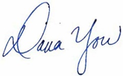

Dana Yow

Executive Director